— FOR IMMEDIATE RELEASE —
Electromate Celebrates 40 Years of Engineering Excellence
and Commitment to Canadian Automation
Marking four decades of technical expertise, trusted partnerships, and a people-first culture in Canada's mechatronics and robotics industries.

VAUGHAN, ONTARIO, November 1, 2026 – Electromate Inc., a leading Canadian distributor of precision motion control, mechatronic, and robotic solutions, proudly celebrates its 40th anniversary, marking four decades of helping Canadian engineers and manufacturers solve complex automation challenges.

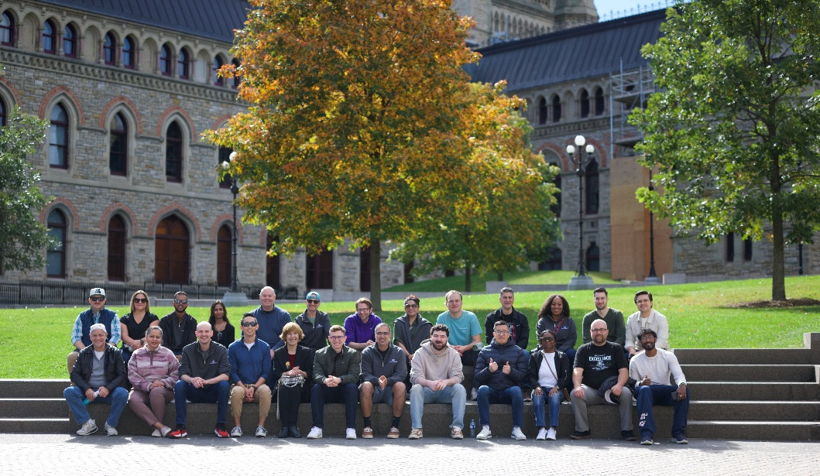
Founded on November 1, 1986, Electromate has grown into a respected Canadian supplier of advanced automation technologies, serving customers across a broad range of industries, including aerospace, medical technology, robotics, advanced manufacturing, and industrial automation.

Today, Electromate provides engineers with access to an extensive portfolio of precision motion control and robotic technologies from globally recognized manufacturers, including maxon, Harmonic Drive, Kollmorgen, Galil Motion Control, and many others. Its solutions range from individual components to integrated mechatronic systems designed to meet demanding application requirements.

Four Decades of Trusted Partnerships

Electromate's success has been built on enduring relationships with customers, suppliers, and employees. By combining cutting-edge technology with knowledgeable application engineering support, the company has established itself as a trusted resource for Canadian engineers seeking reliable, application-specific automation solutions.

Its long-standing partnerships with leading international manufacturers allow Electromate to bring advanced technologies to the Canadian market while providing the local technical expertise, product selection, and customer support that engineers require.

A Culture Built Around People

Beyond its technical accomplishments, Electromate takes particular pride in its workplace culture. The company was recently recognized as one of Canada's Best Workplaces by Great Place to Work Canada, ranking 95th nationally in 2026.

This recognition reflects Electromate's ongoing commitment to creating a workplace where employees feel valued, supported, and empowered to contribute to the company's success.

"Reaching our 40th anniversary is a milestone that fills me with tremendous pride and gratitude," said Warren Osak, President of Electromate Inc. "Our success has never been about any one person. It's the result of four decades of dedication from our employees, the confidence our customers have placed in us, and the strong relationships we've built with our manufacturing partners. I'm especially proud of the culture we've created and the reputation we've earned for technical expertise, integrity, and customer service. As we celebrate this milestone, I'm equally excited about the opportunities ahead and our continued role in supporting the growth of automation and robotics in Canada."

Looking Ahead

As automation, robotics, and intelligent motion control technologies continue to advance, Electromate remains focused on helping Canadian companies improve productivity, precision, and manufacturing capabilities.

With increasing demand for sophisticated robotic systems, integrated mechatronic solutions, and intelligent automation components, Electromate is well positioned to support the next generation of engineering applications.

While the technologies will continue to evolve, the company's guiding principles remain unchanged: technical excellence, trusted relationships, exceptional customer service, and a commitment to its people.

"Our first 40 years have given us a strong foundation," added Osak. "Our responsibility now is to build on that foundation, embrace new technologies, and ensure Electromate continues to be a company that customers, suppliers, and employees are proud to be associated with."

About Electromate Inc.

Founded in 1986 and headquartered in Vaughan, Ontario, Electromate Inc. is a leading Canadian distributor of precision motion control, mechatronic, and robotic solutions. Electromate's core purpose is to help manufacturers compete globally by building better machines using differentiated automation technologies. Through partnerships with leading global manufacturers, Electromate provides advanced automation solutions, application engineering expertise, and technical support to help customers design and build reliable, high-performance machines and complex automation and robotic systems. For more information, visit www.electromate.com.

Media Contact

Electromate Inc.
Vaughan, Ontario, Canada
Website: https://www.electromate.com

